**Software Design and Architecture**



Lab # 04

Class Diagram in Visual Paradigm/Lucid Chart

Instructor: Mazhar Iqbal

Email: fariba.laiq@nu.edu.pk

Course Code: CL1002

Semester Spring 2023

Department of Computer Science,

National University of Computer and Emerging Sciences FAST Peshawar Campus

# **Class Diagram**

A class diagram is a kind of UML diagram that shows the objects that are required and the relationships between them. It provides detailed information about the properties and functions of the classes. It presents the structural and object oriented view of the system.

## Class Notation

A class notation consists of three parts:

* **Class Name**
* **Class Attributes**
* **Class Operations**

## Class Relationships

A class may be involved in one or more relationships with other classes.

Inheritance/Generalization:

Generalization:

A generalization is a relationship between a parent class (superclass) and a child class (subclass). In this, the child class is inherited from the parent class.  
For example, The Current Account, Saving Account, and Credit Account are the generalized form of Bank Account.

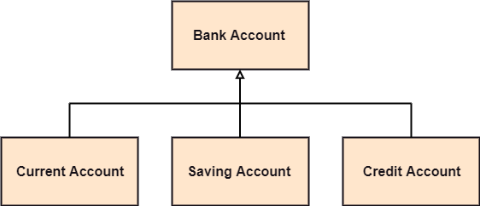

Association:

It describes a static or physical connection between two or more objects. It depicts how many objects are there in the relationship.

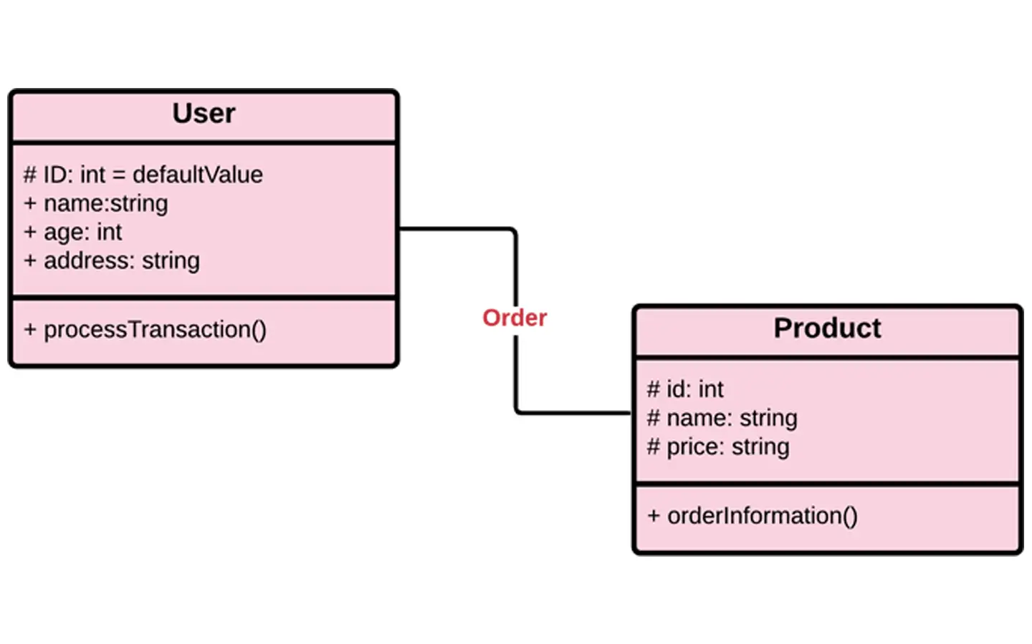

A teacher is associated with multiple students.  
Or  
a teacher provides instructions to the students.

**Multiplicity:**

It defines a specific range of allowable instances of attributes. In case if a range is not specified, one is considered as a default multiplicity.

Aggregation:

An aggregation is a subset of association, which represents has a relationship. It is more specific then association. It defines a part-whole or part-of relationship. In this kind of relationship, the child class can exist independently of its parent class.

 In UML, aggregation is shown by an open diamond on the end of the association line that points to the parent (aggregated) class.

The company encompasses a number of employees, and even if one employee resigns, the company still exists.

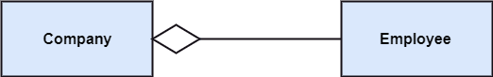

**Example:**  
A car needs a wheel, but it doesn’t always require the same wheel. A car can function adequately with another wheel as well.

Composition:

The composition is a subset of aggregation. It portrays the dependency between the parent and its child, which means if one part is deleted, then the other part also gets discarded. It represents a whole-part relationship.

A contact book consists of multiple contacts, and if you delete the contact book, all the contacts will be lost.

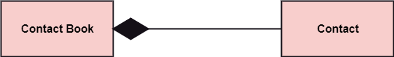

**Example:**  
A file is placed inside the folder. If one deletes the folder, then the file associated with that given folder is also deleted.

**PROCEDURE**

Perform the steps below to create a UML class diagram in Visual Paradigm.

1. Select **File > New** **Diagram** from the application toolbar.
2. In the **New Diagram** window, select, **UML Diagrams** and then **Class Diagram**.
3. Click **Next**.
4. Enter the diagram name and description.
5. Click **OK**.

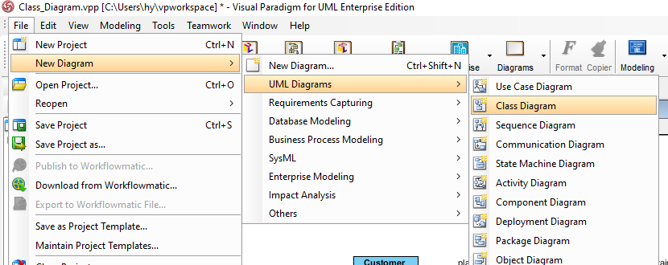

### **Creating class**

To create a class in a class diagram, click **Class** on the diagram toolbar and then click on the diagram.

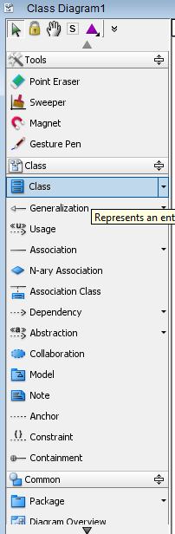

### **Add Attributes/ Methods to Class**

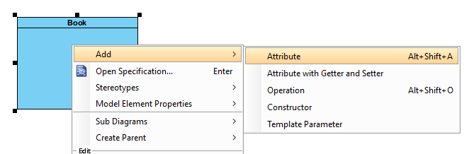

## Class Diagram from description

In an online shopping system, a customer places an order that contains one or more items. At any time, his cart contains one or more items. An order has a payment either by cash on delivery or using a credit card.

